CS575/475

Email: [huanchih@oregonstate.edu](mailto:huanchih@oregonstate.edu)

Name: Chih Hsuan Huang

ID: 934554197

Project #1

OpenMP: Monte Carlo Simulation

Machine: rabbit

NUMTIMES: 20

|  |  |  |  |
| --- | --- | --- | --- |
| Threads | Trials | Probability | MegaTrials/Sec |
| 1 | 1 | 0 | 0.6 |
| 1 | 10 | 40 | 4.7 |
| 1 | 100 | 55 | 18.32 |
| 1 | 1000 | 56.6 | 18.07 |
| 1 | 10000 | 57.02 | 16.19 |
| 1 | 100000 | 56.79 | 26.36 |
| 1 | 500000 | 57.01 | 38.1 |
| 1 | 1000000 | 56.91 | 37.79 |
| 2 | 1 | 0 | 0.35 |
| 2 | 10 | 30 | 2.94 |
| 2 | 100 | 53 | 21.27 |
| 2 | 1000 | 57 | 34.18 |
| 2 | 10000 | 56.47 | 29.73 |
| 2 | 100000 | 56.85 | 35.31 |
| 2 | 500000 | 56.94 | 64.65 |
| 2 | 1000000 | 57.05 | 64.1 |
| 4 | 1 | 0 | 0.23 |
| 4 | 10 | 70 | 2.79 |
| 4 | 100 | 61 | 28.17 |
| 4 | 1000 | 58.1 | 65.96 |
| 4 | 10000 | 57.24 | 61.54 |
| 4 | 100000 | 56.95 | 66.31 |
| 4 | 500000 | 56.9 | 104.75 |
| 4 | 1000000 | 56.92 | 114.61 |
| 6 | 1 | 0 | 0.25 |
| 6 | 10 | 50 | 2.21 |
| 6 | 100 | 51 | 20.01 |
| 6 | 1000 | 56.9 | 92.86 |
| 6 | 10000 | 55.94 | 91.98 |
| 6 | 100000 | 56.85 | 92.94 |
| 6 | 500000 | 56.97 | 138.1 |
| 6 | 1000000 | 57.04 | 198.49 |
| 8 | 1 | 100 | 0.23 |
| 8 | 10 | 50 | 2.18 |
| 8 | 100 | 54 | 20.23 |
| 8 | 1000 | 57.3 | 100.63 |
| 8 | 10000 | 56.9 | 127.27 |
| 8 | 100000 | 57.26 | 124.51 |
| 8 | 500000 | 57.02 | 169.36 |
| 8 | 1000000 | 57.04 | 217.54 |

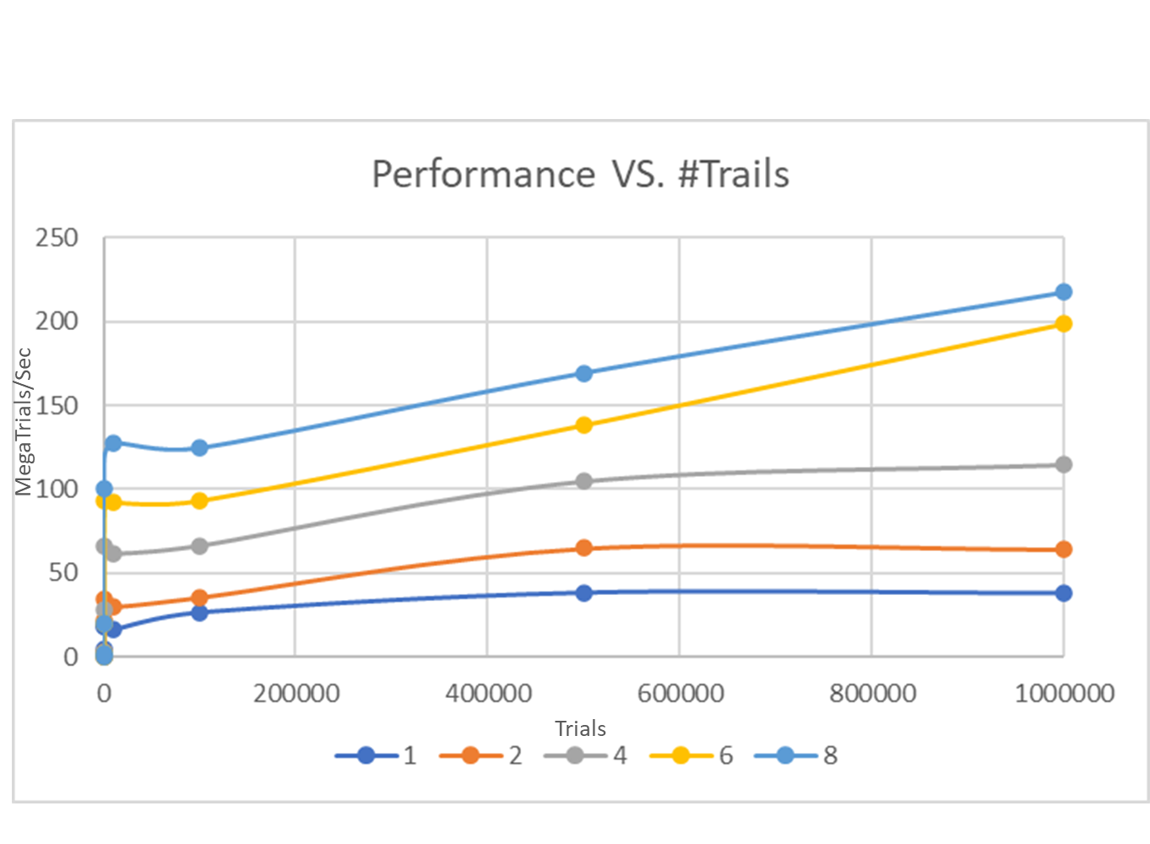Graph1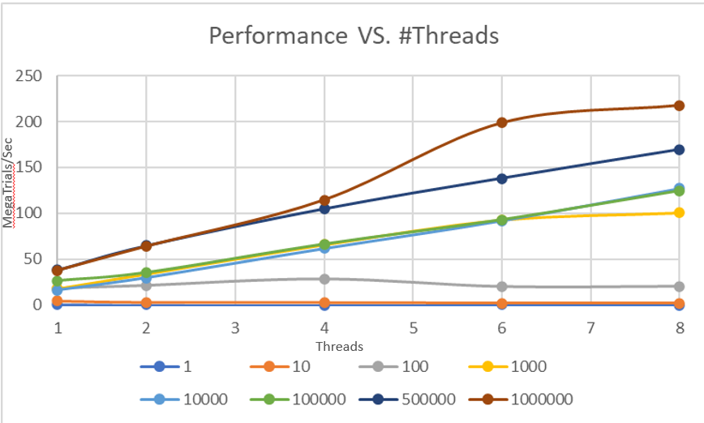

Graph2

Good estimate of the Probability $$\frac{56.91+57.05+56.92+57.04+57.04}{5}=56.992\%$$

Estimate of Speedup (max number of trials 1000000)

Speedup = (Peak Performance 8 threads) / (Peak performance 1 thread)

Speedup $=\frac{Peak Performance n threads}{Peak performance 1 thread}$

Speedup from 1 threads to 2 threads = $\frac{64.1}{37.79}$ = 1.71

Speedup from 1 threads to 4 threads = $\frac{114.61}{37.79}$ = 3.03

Speedup from 1 threads to 6 threads = $\frac{198.49}{37.79}$ = 5.25

Speedup from 1 threads to 8 threads = $\frac{217.54}{37.79}$ = 5.76

Estimate of Fp:

$$Fp = \frac{n}{n-1}×(1-(\frac{1}{S}))$$

$Fp = \frac{2}{1}×(1-(\frac{1}{1.71})) =$ 0.821

$Fp = \frac{4}{3}×(1-(\frac{1}{3.03})) =$ 0.894

$Fp = \frac{6}{5}×(1-(\frac{1}{5.25})) =$ 0.972

$Fp = \frac{8}{7}×(1-(\frac{1}{5.76})) =$ 0.944

Given this Parallel Fraction, what would the maximum speedup be if you could throw hundreds of cores at it?

$$maxSpeedup= \frac{1}{1-Fp}$$

$$maxSpeedup 1 to 2= \frac{1}{1-0.821}=5.59$$

$$maxSpeedup 1 to 4= \frac{1}{1-0.894}=9.43$$

$$maxSpeedup 1 to 6= \frac{1}{1-0.972}=35.71$$

$$maxSpeedup 1 to 8= \frac{1}{1-0.944}=17.86$$

Therefore, when hundreds of cores are available, the maximum speedup that can be expected ranges from approximately 5.59 to 35.71.

Commentary

The line in graph 1 fluctuates at the beginning, that is, there are peaks and troughs in the rising process. This may indicate that the system encounters a performance bottleneck or resource competition at some points, resulting in a temporary decline in performance. And the line levels off after reaching a certain point, which indicates that the system has reached the upper limit of its processing capabilities.

In graph 2, the line rises and slows down or decreases after a certain number of threads. This may mean that adding more threads has less impact on performance, or even causes performance loss due to the overhead of context switching. The lines have large fluctuations at certain points in the middle, which reflects uneven load distribution or that the system is having problems adjusting and optimizing load distribution.